Checklist Part 4B: Transcript for Conference Presentation [required]
If you are not used to presenting research in English, it is helpful to write out a complete transcript containing all that you plan to say. For this Academic Communication course, you are required to write a transcript, and it is worth 10% of your final exam grade (=course grade). You need to bring your transcript to Lesson 8. Writing a transcript greatly helps you to prepare a high-quality presentation. You may or may not use the transcript when you actually present your paper, but you definitely will NOT be simply reading your transcript (you need to look at and speak to your audience!).

A transcript contains a written record of everything you plan to say when you give your presentation. This means every word and full sentences – exactly what you could say! This includes even “Good afternoon” at the beginning (if it will be given in the afternoon) and the exact words you plan use at the very end to invite questions. You will NOT be just reading the transcript, so what you actually say in the real presentation will not be exactly what is in the transcript. However, planning how to say it perfectly will help you very, very, very much to present well.

Your transcript text must be organized by slide. For each slide, give the time you will spend on the slide, the exact words and sentences you will say while that slide is showing, and an image of the slide. You can insert images into your document, or you can have them on separate sheets, as long as it is clear which image goes with which slide text and time (e.g., by numbering the slides if they are printed separately). You can choose your own format, but don’t let the images get too small. Another student will need to be able to clearly see your slides in Lesson 8.

One good format is illustrated below, with each slide image half the width of the sheet. For each slide, show a picture of the slide, the time you will spend on it, and what you will say while the slide is visible. In the transcript you will have: picture – timing – text – picture – timing – text – picture – etc. Note that you are required to specify the timing for each slide. Also, it is a good idea to indicate if the slide is part of the Introduction, Body, or Conclusion.

Good transcript: 10% Not having timing for each slide: 5% off Text missing or not organized by slide: 5% off

Slide 6 (Body):  Time: 20 seconds (2:20-2:40)  Say:  Zircon crystals are very durable but not so durable that they could survive in a molten rock surface. This means that the zircons we found must have formed after the Hadean age ended. That leads us to this question: How old are the zircons? | 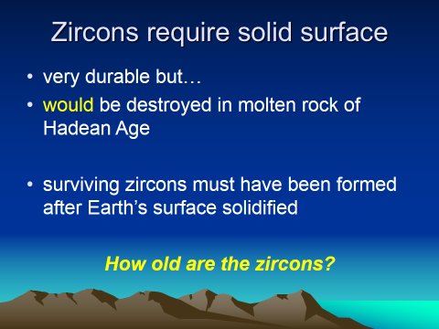
Slide 7 (Body):  Time: 40 seconds (2:40-3:20)  Say:  So how can we determine how old the zircon crystals are? It turns out that this is not hard. When zircons form, some other substances can get into the crystal as impurities.  Lead does not fit into the lattice, so new zircons have absolutely no lead. On the other hand, uranium does fit, so uranium exists in the crystals in trace amounts when they are formed. Uranium radioactively decays into lead, so we know that all the lead we find now in a zircon must have come from uranium. Since the half-life of uranium is known, we can compare ratios of uranium to lead and determine how long the uranium has been in the crystal, to an accuracy of 1%, which is an accuracy of about 40 million years. | 