SSSTC2019-Instructions for Abstracts (Title)
Presenting Author,¹ Co-Author,² Corresponding Author^{1*}
¹Affiliation, e-mail, city, and country (Author Organization)
²Other authors’ affiliation, city, country
* Email:
This is a template for preparing your abstract manuscript. To format your manuscript correctly, please use the fonts and type sizes defined in this document. A short abstract of your contribution may be inserted here. One page in length is encouraged and only one additional page is allowed, if needed. Please use short, direct sentences. It should be as concise as possible.
For the manuscript written in English, the abstract title should be written with first letters capitalized, 12 point. The standard font for the manuscript is Times New Roman for the text and Symbol for special characters. The figure and table(s) should be cited in the text, numbered in order of appearance and followed by a centered title.
References [1] must be made as shown in the example given below.
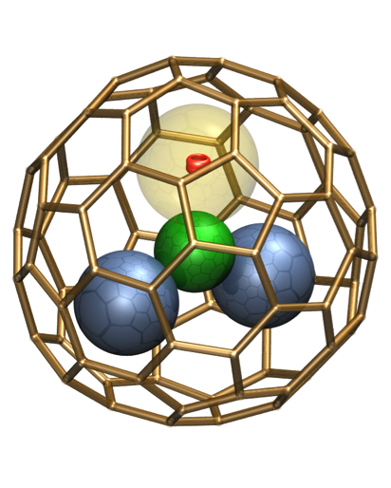

Fig. 1 Figure caption.

References
1. P. Author, S. Author and T. Author, Journal Name, Year, Volume, Page.
2. P. Author, S. Author and T. Author, Journal Name, Year, Volume, Page.

Biography
Corresponding Author is professor in School of XXXXXX at XXXXXX University. He received his PhD in XXXXXX University in 19XX. After a postdoctoral training in XXX, he joined XXX University since 20XX. He published over XXX peer-reviewed papers regarding XXX. Current research focuses on XXXXXX. Honors and awards include…..

Your Shot
(Please paste your photo left side)

